

1. Solve the equation by factoring.

1. b. c. d.

2. Solve the equation by graphing.

1. b. c. d.

3. Solve the equation by using square roots.

a. b. c. d.

4. Find the value of b that makes the expression a perfect square trinomial. $x^{2}+bx+36$

a. 18 b. 12 c. 6 d. 4

5. Find the value of c that makes the expression a perfect square trinomial. $x^{2}+16x+c$

a. 4 b. 8 c. 256 d. 64



6. Simplify the radical.

a. b. c. d.

7. Simplify the radical.

a. b. c. d.

8. Solve by using the quadratic formula.

a. b. c. d.

9. The discriminant tells us the __________________

i. number of zero’s. ii. the number and type of solutions. iii. number of x-intercepts.

iv. where the quadratic crosses the x-axis. v. the solutions.

a. i and ii b. i and iii c. iv and v d. i , ii, iii e. i, ii, iii, iv, v

10. If the discriminant is positive and a perfect square then the roots are _______________________?

a. Complex b. Real & Irrational c. Real & Rational

11. If the discriminant is positive and not a perfect square then the roots are _______________________?

a. Complex b. Real & Irrational c. Real & Rational

12. If the discriminant is zero then the roots are _______________________?

a. Complex b. Real & Irrational c. Real & Rational



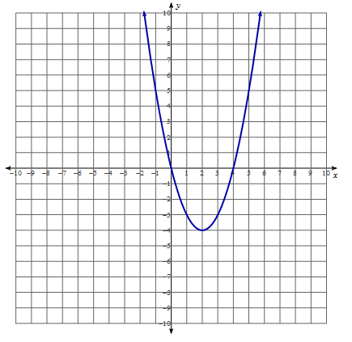13. The graph to the right has how many solutions?

a. one b. two c. zero d. cannot determine

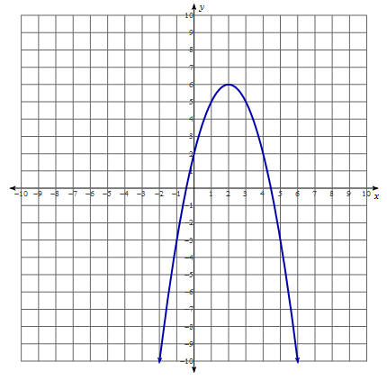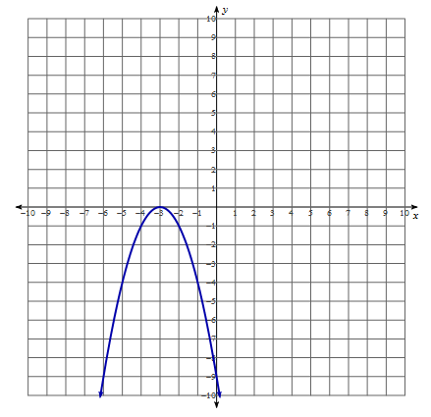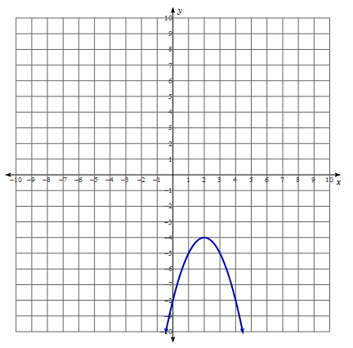14. Match the graph to the value of the discriminant.

a. Negative b. Positive c. Zero

15. If the discriminant is negative then the roots are _______________________?

a. Complex b. Real & Irrational c. Real & Rational

16. Calculate the discriminant to the equation $y=4x^{2}-2x+5$

a. 84 b. 76 c. -84 d. -76

17. Simplify the expression.

a. b. c. d.

18. Simplify the expression. $\left(x^{2}\right)\left(x^{3}\right)$

a. $x^{5}$ b. $x^{6}$ c. $x^{9}$ d.



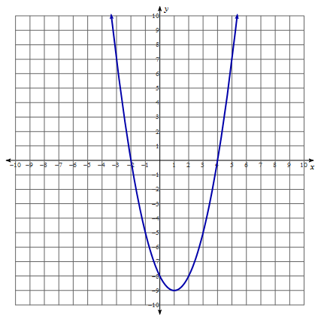19. Match the graph to the type and number of roots the equation would have.

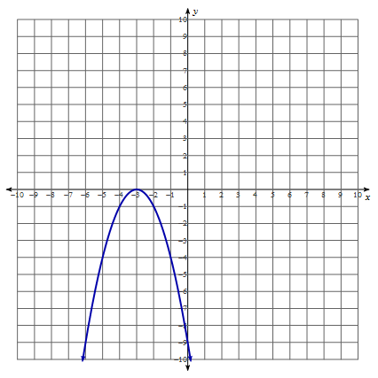

a. 2 Real Numbers a. 2 Real Numbers

b. 1 Real Number b. 1 Real Number

c. 2 Complex Numbers c. 2 Complex Numbers

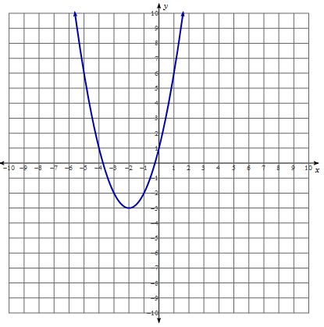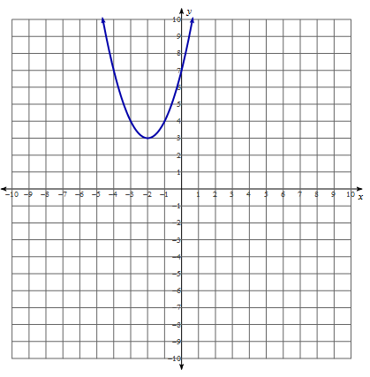

a. 2 Real Numbers a. 2 Real Numbers

b. 1 Real Number b. 1 Real Number

c. 2 Complex Numbers c. 2 Complex Numbers

20. Simplify the expression.

a. b. c. d.

21. Simplify and rewrite in radical form.

a. b. c. d.

22. Simplify and rewrite in radical form. ${\left({x^{\frac{2}{3}}x}^{\frac{4}{5}}\right)}^{\frac{5}{2}}$

a. $\sqrt[3]{x^{11}}$ b. $\sqrt[11]{x^{3}}$ c. $\sqrt[30]{x^{119}}$ d.



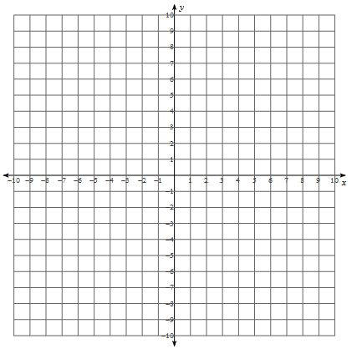23. Graph the function $y=\sqrt{x-4}+1$. What is the starting point?

a. (-4, 1) b. (4, 1) c. (-4,-1) d. (-4, -1)

|  |  |
| --- | --- |
| x | y |
|  |  |
|  |  |
|  |  |
|  |  |
|  |  |

24. What is the domain and range for the previous graph?

a. Domain: $x≥-4$, Range: $y≥1$ b. Domain: $x≥4$, Range: $y≥1$

c. Domain: $x≥-4$, Range: $y≥-1$ d. Domain: $x≥-4$, Range: $y≥-1$

e. Domain: , Range:

25. Graph the function $y=-2\sqrt[3]{x+2}-3$. What is the inflection point?

a. (-2, 3) b. (2, 3) c. (-2,-3) d. (2, -3)

|  |  |
| --- | --- |
| x | y |
|  |  |
|  |  |
|  |  |
|  |  |
|  |  |

26. What is the domain and range for the previous problem?

a. Domain: , Range: b. Domain: , Range:

c. Domain: , Range: d. Domain: , Range:

e. Domain: , Range:

27. Graph the function $y=x^{3}+x^{2}-6x$. What is the relative maximum?

a. (2, 8) b. (-2, 8) c. (-1.78, 8.21) d. (-1.78, -8.21)

|  |  |
| --- | --- |
| x | y |
|  |  |
|  |  |
|  |  |
|  |  |
|  |  |

28. What is the domain and range for the previous question?

a. Domain: $x≥-2$, Range: $y≥8$ b. Domain: $x≥-1.78$, Range: $y≤8.21$

c. Domain: $x≤-2$, Range: $y≥-8$ d. Domain: $x≤-1.78$, Range: $y≤-8.21$

e. Domain: , Range:

29. Graph the function $y=-\left|x+1\right|-3$. What is the vertex?

a. (-1, 3) b. (1, 3) c. (-1,-3) d. (1, -3)

|  |  |
| --- | --- |
| x | y |
|  |  |
|  |  |
|  |  |
|  |  |
|  |  |

30. What is the domain and range for the previous problem?

a. Domain: , Range: b. Domain: , Range:

c. Domain: , Range: d. Domain: , Range:

e. Domain: , Range:



31. Simplify the expression.

a. b. c. d.

32. Simplify the expression.

a. b. c. d.

33. Find the product.

a. b. c. d.

34. Divide.

a. b. c. d.

35. Divide.

a. b. c. d.



36. Divide.

a. b. c. d.

37. Find all of the zeros of

a. b. c. d.

38. Find all of the zeros of

a. b. c. d.



39. Solve the equation

a. x = 2 b. x = 4 c. d. x = 8

40. Solve the equation $\sqrt{2x^{2}+51}+1=0$

a. x = 5 b. x = -5 c. x = 5, x = -5 d. no solution

41. Solve the equation algebraically $\left|2x-4\right|-7=-1$

a. x = 5 b. x = -1 c. x = 5, x = -1 d. no solution

42. Solve the equation graphically $5\left|9-3x\right|=60$

a. x = 7 b. x = -1 c. x = 7, x = -1 d. no solution

43. The population for rural towns in MN is represented by the equation $P=1.32x^{\frac{4}{3}}$ where x is the number of homes in the town. If the population of a town is 825, how many homes are there?

a. 825 homes b. 10214 homes c. 5344 homes d. 125 homes